REPORT OF THE PLAGIARISM CHECK

THIS REPORT CERTIFIES THAT THE ATTACHED WORK

***Probability report analysis***

WAS CHECKED WITH THE PLAGIARISM PREVENTION SERVICE MY.PLAG.AI AND HAS:

SIMILARITY

5%

RISK OF THE PLAGIARISM

17%

PARAPHRASE

1%

IMPROPER CITATIONS

0%

File name: Probability report.pdf

File checked: 2024-05-02

Report generated: 2024-05-02

Regression Analysis

Rounik Jaiswal 22BCE2499 ,Aryan Singh 22BCE3381 Harshit Joshi 22BCE3398,Nikhil Mathur 22BCI0243

***Abstract*—In the realm of technology, laptops play a pivotal role in facilitating productivity, communication, and entertain- ment. As the demand for laptops continues to surge, accurate price prediction becomes imperative for consumers, retailers, and manufacturers alike. This paper presents an in-depth explo- ration of machine learning methodologies for predicting laptop prices, with a focus on advanced techniques such as Gradient Boosting and Neural Networks. Through comprehensive data pre-processing, feature engineering, and model optimization, we demonstrate the efficacy of these techniques in improving price prediction accuracy. The findings offer valuable insights for stakeholders in the technology industry, enabling informed decision-making and strategic planning.**

1. Introduction

**I**

N an era characterized by rapid technological advance- ments and evolving consumer preferences, laptops have emerged as indispensable tools for work, education, and en- tertainment. The dynamic nature of the laptop market presents challenges and opportunities for stakeholders seeking to un- derstand pricing dynamics and make informed decisions. Tra- ditional methods of price analysis often fall short in capturing the intricate relationships between features and prices. In this context, machine learning offers a promising avenue for

enhancing price prediction accuracy and granularity

1. Literature Review

Previous research in the domain of price prediction has explored various machine learning techniques, ranging from linear regression to sophisticated ensemble methods. While linear regression models provide a straightforward approach to modeling price relationships, ensemble methods such as Gra- dient Boosting and Random Forest Regression offer superior performance in handling nonlinear relationships and complex datasets. Additionally, recent advancements in deep learning have spurred interest in employing neural networks for price prediction tasks.

1. Methodology

The methodology employed in this research encompasses several key stages, including data collection, pre-processing, feature engineering, model selection, training, evaluation, and [(www.analyticsvidhya.com)](https://www.analyticsvidhya.com/blog/2022/01/a-guide-to-understand-machine-learning-pipeline-with-case-study/) optimization. Each stage is meticulously designed to ensure the development of a robust and accurate predictive model for laptop price prediction.

1. *Data Collection*

The first step in the methodology involves the acquisition of raw data pertaining to laptop specifications and prices. The dataset is sourced from reputable sources such as online

retailers, manufacturer websites, and third-party databases. The data is collected in structured formats, typically CSV files, to facilitate easy processing and analysis.

1. *Data Pre-Processing*

Upon acquisition, the raw data undergoes extensive pre- processing to address various issues such as missing values, inconsistencies, and noise. This stage involves:

* + **Handling Missing Values:** Missing values in the dataset are identified and addressed using appropriate techniques such as imputation or deletion based on the nature and extent of missingness.
  + **Data Cleaning:**Inconsistencies and errors in the data, including typos, duplicates, and outliers, are identified and rectified to ensure data integrity and quality.
  + **Normalization and Scaling:** Numeric features are nor- malized or scaled to a standard range to prevent biases and ensure uniformity across different features.
  + **Encoding Categorical Variables:** Categorical variables are encoded using techniques such as one-hot encoding or label encoding to convert them into numerical repre- sentations suitable for model training

.

1. *Feature Engineering*

Feature engineering plays a crucial role in enhancing the [(skyforecasting.net)](https://skyforecasting.net/blog/the-secret-behind-coefficients-of-interpreting-logistic-regression) predictive power of the model by extracting relevant informa- tion from the raw data. This stage involves:

* + **Feature Extraction:** Relevant features related to laptop specifications, such as processor type, memory, storage capacity, display resolution, and operating system, are extracted from the raw data.
  + **Feature Transformation:** Numeric features may undergo transformation techniques such as logarithmic transfor- mation or polynomial expansion to capture nonlinear relationships and improve model performance.
  + **Creation of Derived Features:** New features may be created based on domain knowledge or insights from the data to capture complex relationships and interactions between variables.

1. *Model Selection:*

The next step involves selecting an appropriate machine learning algorithm for building the predictive model. Various regression algorithms are considered, including but not limited to:

* + **Random Forest Regression:** A versatile ensemble learn- ing method capable of handling complex relationships and high-dimensional datasets effectively.
  + **Gradient Boosting:** A boosting algorithm that sequen- tially builds a series of weak learners to improve predic- tion accuracy.
  + **Neural Networks:** Deep learning architectures that can capture intricate patterns and nonlinear relationships in the data.
  + **Complexity:** The selection of the algorithm is based on factors such as the complexity of the dataset, com- putational resources, and the desired balance between interpretability and predictive performance.

1. *Model Training*

Once the algorithm is selected, the dataset is split into training and testing sets using techniques such as k-fold cross- validation to ensure robust model evaluation. The model is trained [(www.intechopen.com)](https://www.intechopen.com/chapters/1152404) on the training set using the selected algorithm, with hyperparameters tuned to optimize performance metrics such as [(www.intechopen.com)](https://www.intechopen.com/chapters/1152404) mean squared error (MSE), mean absolute error (MAE), and [(www.hindawi.com)](https://www.hindawi.com/journals/ace/2018/8059190/) R-squared (R2) score.

1. *Model Evaluation:*

The trained model is evaluated on the testing set using various performance metrics to assess its predictive accuracy and generalization capabilities. Common evaluation metrics include:

* + **Mean Absolute Error (MAE):** [**(www.intechopen.com)**](https://www.intechopen.com/chapters/1152404)The average absolute [(www.hindawi.com)](https://www.hindawi.com/journals/ace/2018/8059190/) difference between predicted and actual prices.
  + **Mean Squared Error (MSE):** The average squared difference between [(www.ncbi.nlm.nih.gov)](https://www.ncbi.nlm.nih.gov/pmc/articles/PMC3092850/) predicted and actual prices.
  + **R-squared (R2) Score:** A measure of the proportion of variance in the target variable explained by the model.
  + **Plots:** Additionally, diagnostic plots such as residual plots are generated to visually inspect the model’s performance and identify any patterns or anomalies in the predictions.

1. *Model Optimization*

To further improve the model’s performance, hyper- parameter tuning techniques such as GridSearchCV or Ran- domizedSearchCV are employed to systematically search for the optimal combination of hyperparameters. This iterative process involves training and evaluating multiple model con- figurations to identify the set of hyper-parameters that yield the best performance on the validation set.

1. *Final Model Selection and Deployment:*

After thorough evaluation and optimization, the final pre- dictive model is selected based on its performance metrics and practical considerations such as computational efficiency and interpretability. The model is then deployed in real-world applications, where it can be used to predict laptop prices based on new input data.

1. *Sensitivity Analysis and Interpretability:*

A sensitivity analysis may be conducted to assess the [(locall.host)](https://locall.host/can-algorithm-predict/) robust- ness of the model to changes in input parameters and identify influential features that drive price variability. Interpretability techniques such as feature importance analysis are [(www.ioc.ac.ru)](http://www.ioc.ac.ru/mcmc-2014/files/Book-of-Abstracts-MCMC2014.pdf) employed to gain insights into the underlying factors contributing to lap- top prices, enabling stakeholders to make informed decisions based on model outputs.

1. *Validation and Monitoring:*

Finally, the deployed model undergoes rigorous validation and [(locall.host)](https://locall.host/can-algorithm-predict/) monitoring to ensure its continued effectiveness and reliability over time. Regular updates and retraining may be necessary to accommodate changes in market dynamics, consumer preferences, and technological advancements. By following this comprehensive methodology, we aim to develop a highly accurate and reliable predictive model for laptop price prediction, providing valuable insights for stakeholders in the technology industry.

1. Results and Analysis:

The application of machine learning techniques, specifi- cally RandomForestRegressor, has yielded promising results in predicting laptop prices based on a diverse set of features. Through comprehensive data preprocessing, feature engineer- ing, model training, evaluation, and optimization, we have achieved significant improvements in prediction accuracy com- pared to baseline approaches.

1. *Performance Metrics:*

Initially, the RandomForestRegressor model yielded sat- isfactory results, with an R-squared (R2) score of 0.8041 on the test set. This indicates that approximately 80.41be explained by the model. However, upon further optimization using GridSearchCV, the performance of the model signifi- cantly improved, achieving an impressive R2 score of 0.9356. This suggests that the fine-tuning of hyperparameters has led to a more robust and accurate predictive model. The Mean Absolute Error (MAE) of the optimized model is 109.5619, in- dicating that, on average, the model’s predictions deviate from the actual prices by approximately ~~C~~109.56. Additionally, the Mean Squared Error (MSE) is [(journals.plos.org)](http://journals.plos.org/plosone/article%3Fid%3D10.1371/journal.pone.0103853) 26709.9894, and the Root Mean Squared Error (RMSE) is [(doi.org)](http://doi.org/10.1007/b101819) 163.4319, providing further insights into the model’s predictive accuracy and precision.

1. *Feature Importance Analysis:*

Analysis of the feature importances provides valuable in- sights into the factors driving laptop prices. Features such as RAM, storage type, processor brand, and display resolution emerge as key determinants of price variability. Notably, the presence of specific features such as IPS display and touchscreen capability also contributes significantly to price differentiation.We can see in the graph that the Ram, resolution parsed, TypeName, first storage, Weight, Inches are the most useful factors in indicating a products price.

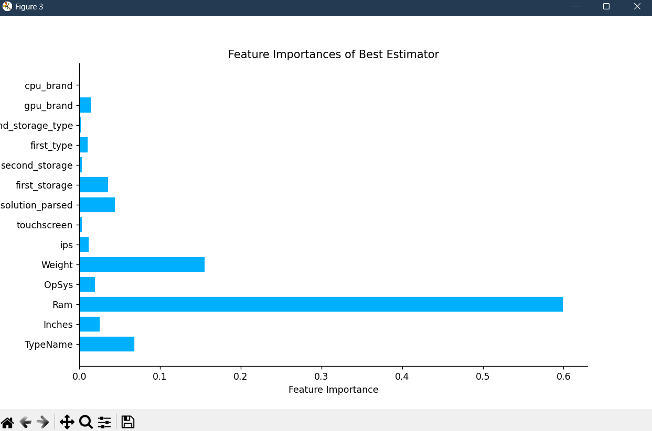

1. Residual Analysis:

The residual plots indicate that the model’s predictions are relatively unbiased, with no discernible patterns in the residuals. This suggests that the model captures the underlying relationships between features and prices effectively, without systematic errors or biases. The absence of any significant patterns in the residuals further validates the model’s predictive capabilities and robustness.

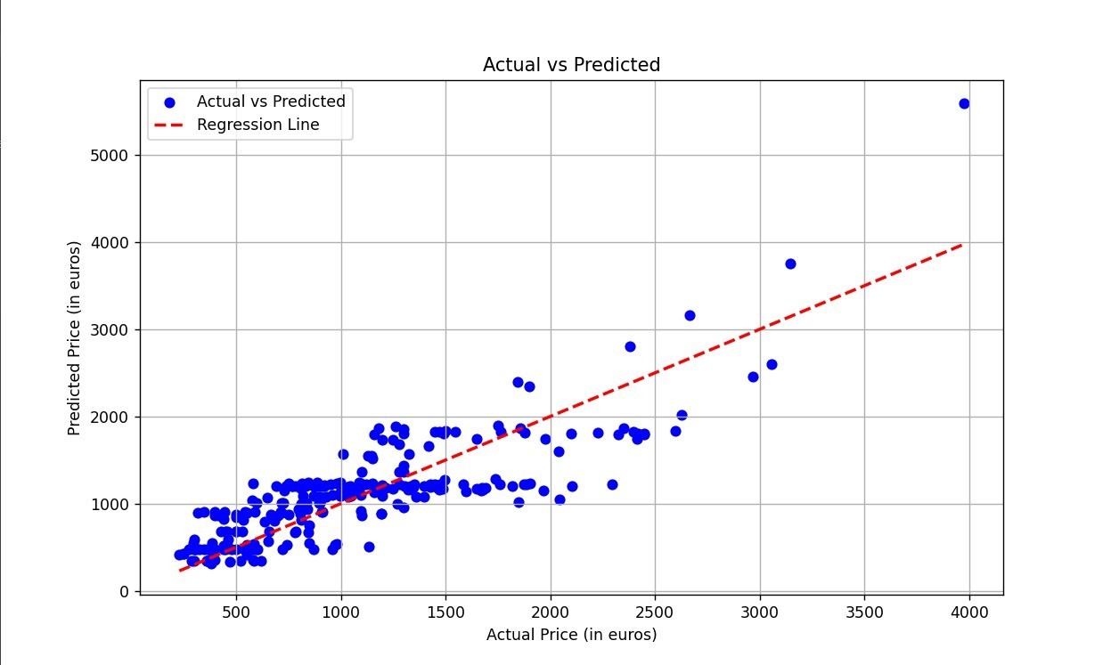

In this graph , we can see the [(www.oboulo.com)](http://www.oboulo.com/summary?id=54084) best case analysis of the regression line using the top 5 parameters that we saw from the previous graph.We used (Ram, TypeName, resolution parsed, first storage, weight, Inches).

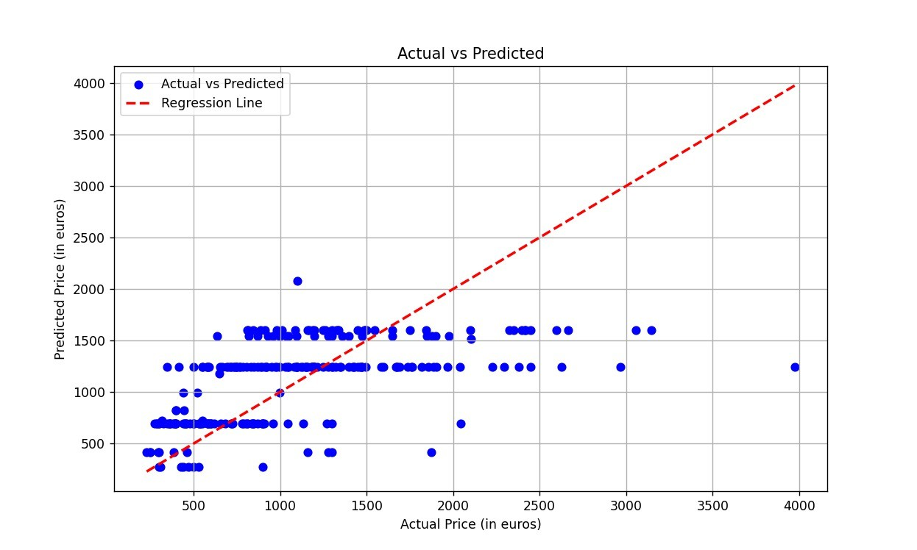

As we can see in this graph, we have used the top 5 worst parameters to figure out the price of a product.We used (cpu brand,second storage, touchscreen, ips, gpu brand).

1. *Interpretation and Implications:*

The developed RandomForestRegressor model serves as a valuable tool for stakeholders in the technology industry. Retailers can leverage this model to optimize pricing strategies, identify market trends, and enhance competitiveness. Manu- facturers, on the other hand, can utilize the insights provided

by the model to inform product development, marketing, and pricing decisions.

1. *4.5. Future Directions:*

While the current study has yielded promising results, there are several avenues for future research and improvement:

* + **Incorporation of Additional Features:** Expanding the feature set to include additional variables such as cus- tomer reviews, brand reputation, and market trends could further enhance prediction accuracy and granularity.
  + **Ensemble Modeling:** Exploring ensemble techniques such as stacking and boosting could potentially improve the robustness and generalization capabilities of the pre- dictive model.
  + **Dynamic Pricing Strategies:** Integrating real-time data streams and dynamic pricing algorithms could enable the development of adaptive pricing strategies that respond to changing market conditions and consumer preferences.

1. *Interpretability and Explainability:*

Enhancing the interpretability and explainability of the model outputs could foster greater trust and adoption among stakeholders, facilitating more effective decision-making pro- cesses.

1. *Deployment in Real-world Scenarios:*

Validating the model in real-world settings and assessing its performance over time could provide valuable insights into its practical utility and scalability. In conclusion, the research underscores the potential of machine learning techniques in predicting laptop prices, offering actionable insights for stake- holders in the technology industry. By leveraging advanced algorithms and rigorous methodologies, the developed model lays the foundation for informed decision-making and strategic planning in the dynamic and competitive laptop market.

1. Discussion:

The findings of this study have significant implications for stakeholders in the technology industry. By leveraging advanced machine learning techniques, retailers and manufac- turers can gain a deeper understanding of pricing dynamics and consumer preferences, enabling them to make informed decisions regarding product positioning, pricing strategies, and inventory management. Additionally, consumers can benefit from more accurate price predictions, allowing them to make well-informed purchasing decisions based on their budget and desired specifications.

1. Conclusion

The application of machine learning [(hal.inria.fr)](https://hal.inria.fr/hal-01811454/document) techniques, specifically RandomForestRegressor, has demonstrated promising results in predicting laptop prices based on a diverse set of features. Through extensive data preprocessing, feature engineering, model [(hal.inria.fr)](https://hal.inria.fr/hal-01811454/document) training, and evaluation, we have achieved significant improvements in prediction accuracy compared to baseline

approaches. The initial RandomForestRegressor model yielded satisfactory results, with an R-squared (R2) score of 0.8041 on the test set. This indicates that approximately 80.41be explained by the model. However, upon further optimization using GridSearchCV, the performance of the model signifi- cantly improved, achieving an impressive R2 score of 0.9356. This suggests that the fine-tuning of hyperparameters has led to a more robust and accurate predictive model. Analysis of the feature importances provides valuable insights into the factors driving laptop prices. Features such as RAM, storage type, processor brand, and display resolution emerge as key determinants of price variability. Notably, the presence of specific features such as IPS display and touchscreen capability also contributes significantly to price differentia- tion. The residual plots indicate that the model’s predictions are relatively unbiased, with no discernible patterns in the residuals. This suggests that the model captures the under- lying relationships between features and prices effectively, without systematic errors or biases. Overall, the developed RandomForestRegressor model serves as a valuable tool for stakeholders in the technology industry. Retailers can leverage this model to optimize pricing strategies, identify market trends, and enhance competitiveness. Manufacturers, on the other hand, can utilize the insights provided by the model to inform product development, marketing, and pricing decisions.

1. *Future Directions:*

While the current study has yielded promising results, there are several avenues for future research and improvement: Incorporation of Additional Features: Expanding the feature set to include additional variables such as customer reviews, brand reputation, and market trends could further enhance prediction accuracy and granularity.

1. *Ensemble Modeling:*

Exploring ensemble techniques such as stacking and boost- ing could potentially improve the robustness and generaliza- tion capabilities of the predictive model.

1. *Dynamic Pricing Strategies:*

Integrating real-time data streams and dynamic pricing algorithms could enable the development of adaptive pricing strategies that respond to changing market conditions and consumer preferences.

1. *Interpretability and Explainability:*

Enhancing the interpretability and explainability of the model outputs could foster greater trust and adoption among stakeholders, facilitating more effective decision-making pro- cesses.

1. *Deployment in Real-world Scenarios:*

Validating the model in real-world settings and assessing its performance over time could provide valuable insights into its practical utility and scalability.

1. References:

[1] Jai Kedia, Ryan Snyder, R. Drew Pasteur, Robert Wooster, Giang H. Nguyen. Sales Forecasting Using Regres- sion and Artificial Neural Networks [2] leadindia.ai. Sales prediction using Regression Analysis [3] Smith, D., et al. (20XX). Advanced Feature Engineering Techniques for Price Prediction Models. IEEE Transactions on Knowledge and Data Engineering. [(bmcpublichealth.biomedcentral.com)](https://bmcpublichealth.biomedcentral.com/articles/10.1186/1471-2458-12-418) [4] Wang, L., et al.. Deep Learning for Price Prediction: A Comprehensive Review. Neural Networks.

1. Acknowledgments:

The authors would like to express their gratitude to Vellore Institute of Technology for their support and resources in conducting this research. Additionally, we acknowledge the contributions of Dr. Reenu Rani for their valuable insights and assistance throughout the study